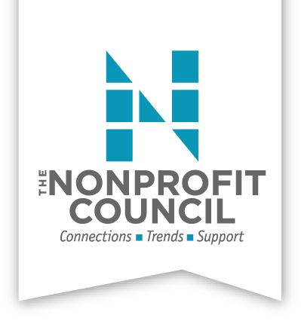
Advocacy Committee
Meeting Notes
June 4, 2018

- Committee Members in attendance: Scott McAninch, Denise Barkhurst, Dawn Dixon, Jerry Moore, Natalie Griffith, Cici Osoma, Nora Oyler, Renee Garvens, Kathy MacNaughton, Carlos Maestas, and Susan Osborne

- Much of our time was spent fleshing out the Advocacy Survey to ensure we were collecting information to use in our brochure. The goal was to get the right information without having members spend too much time searching for answers. Scott and Susan will complete the agreed upon edits and Scott will send out the survey to members by end of the week.

- Jerry shared his preliminary mock-up of the TNC Advocacy brochure. “We Are” will be the message of the brochure and data gathered from the survey will added once we get the results.

- Susan shared the results of the VIA survey sent out to members. There was not an overwhelming response to the survey, with 29 responses. It was decided to add a few of the questions to the Advocacy Survey Scott is sending out in hopes of more responses. Once we have more data on the member’s needs we will decide how to proceed with VIA.

- The City of San Antonio is asking for feedback on the upcoming budget. Natalie suggested that we provide a link to membership so that we have some influence on the budget, including social services. Natalie will provide Scott with the link and Scott will put in the TNC Friday newsletter.

- It was decided to keep monthly meetings on Monday’s at 4:30, but will change to the 3rd Monday of each month.

Next Meeting: July 16, 2018 at Big Brothers Big Sisters from 4:30 – 6:00

