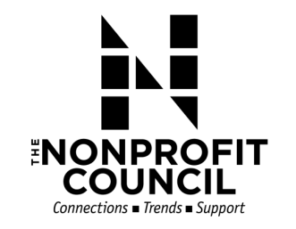

Executive Committee Meeting
Wednesday, August 08, 2018

Meeting Agenda:
- Review of July Financials
  - TNC Y-T-D & Balance Sheet
- 2019 TNC Budget Review & Vote
  - Big Give Budget
  - TNC Budget
- Committee Updates
  - Membership: Leslie Palmer
  - Advocacy: Susan Osborne
  - Leadership Development: Angela White
- Issue in Profile Update
- Big GIG Update – Presenting Sponsor confirmed!
- Other Business?

