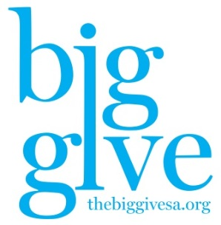

Operations Support Sponsorships NPO Service Charge 2% Fee
($110,000) ($18,000) ($105,600) ($50,000)
Osinger Foundation $15,000 Schriver|Carmona $5,000 550 participating NPOs
Newman Foundation $15,000 Wave Healthcare $5,000
SAAFDN $100,000 (increase) Documation $1,500
Ewing Halsell $10,000 STMM $1,000
Najim Foundation $10,000 G&A 1,000
Hartman Foundation $10,000 Huffman Developments $1,000
Spurs $1,000
Armstrong Vaughan $2,500
Prize Awards ($61,000)
60 total NPO winners
Day Prizes
12am-6am ($4,000) 4 npo winners
xs $1,000
s $1,000
m $1,000
l $1,000
6am-8am, 8am-10am, 10am-Noon, Noon-2pm, 2pm-4pm, 4pm-6pm, 6pm-8pm, 8pm, 10pm, 10pm-11:59am ($36,000) 36 npo winners
xs $1,000
s $1,000
m $1,000
l $1,000
End-of-Day Prizes ($21,000) 20 npo winners
xs $2,000, $1,500, $1,000, $500, $250
s $2,000, $1,500, $1,000, $500, $250
m $2,000, $1,500, $1,000, $500, $250
l $2,000, $1,500, $1,000, $500, $250

